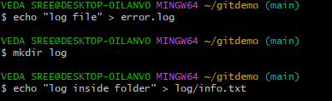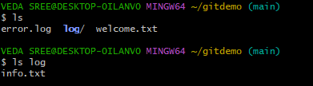**2. Git Ignore**

****1. move to project folder

2. create a folder to ignore and add file in to it and check over comments

3. create .gitignore

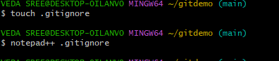

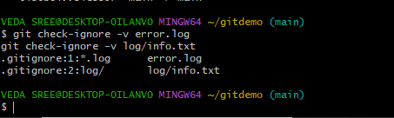

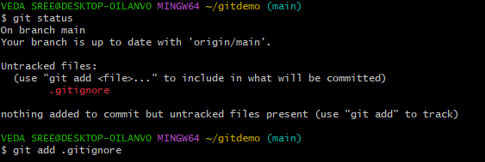4. check status

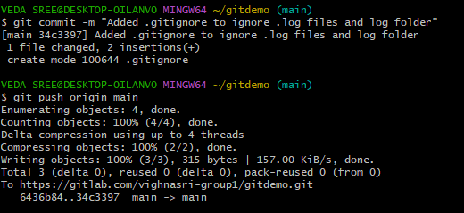5. commit to gitlab